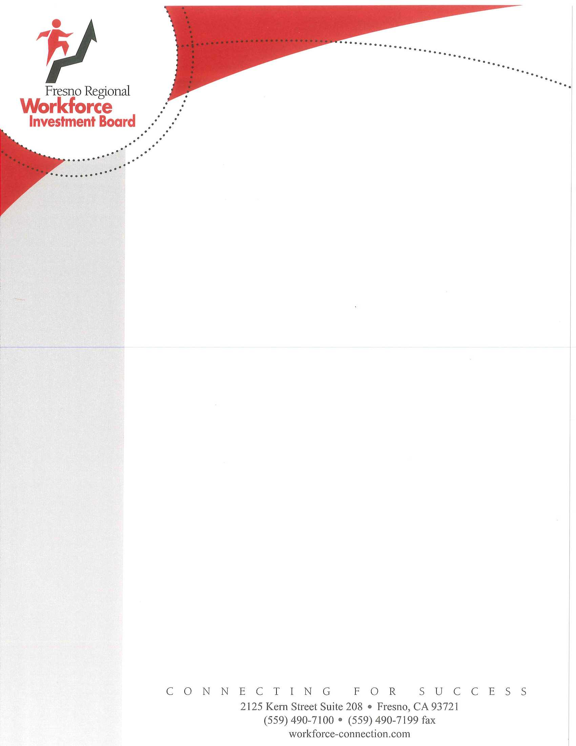

The Fresno Business Services Center and our partners are here to help the business community in response to the spread of COVID-19. Our office continues to monitor the situation and adjusting our workshops and resources as needed. Our conference rooms are still open for public use for the time being, but please note that a maximum of 10 individuals can use a room for the time being, with a minimum of 3-6 feet space between individuals. Our upcoming HR workshops will be provided via webinar format only into the month of April.

For a list of immediate resources available to workers and employers impacted by COVID-19 displacement, please visit the Employment Development Department’s official page of services available: <https://www.edd.ca.gov/about_edd/coronavirus-2019.htm>

The Small Business Administration (SBA) is offering up to $ 2 million in low-interest disaster recovery loans to small businesses that are impacted by COVID-19. Visit their page for more information: <https://www.sba.gov/page/coronavirus-covid-19-small-business-guidance-loan-resources>

Through the Governor’s Executive Order in response to COVID-19, the California Department of Tax and Fee Administration (CDTFA) has the authority to assist individuals and businesses impacted, including granting extensions on filing returns and making payments, relief from interest and penalties, and filing a claim for refund. More information can be found here: <https://www.cdtfa.ca.gov/services/covid19.htm>

The Internal Revenue Service (IRS) has established a special section focused on steps to help taxpayers, businesses and others affected by the coronavirus. <https://www.irs.gov/coronavirus>

The US Department of Labor Occupational Safety and Health Administration (OSHA) has issued a guide on preparing your workplace in response to COVID-19. Visit this here: <https://www.osha.gov/Publications/OSHA3990.pdf?fbclid=IwAR1-wDQOfh0PvUXJsiZhcxYJNxhM7psuPuCfN5L9bCXMZg5nNT9DAGE0OGY>

The Fresno County Economic Development Corporation offers great information on local resources. View more information here: <https://www.fresnoedc.com/news-and-resource-news-and-updates/>